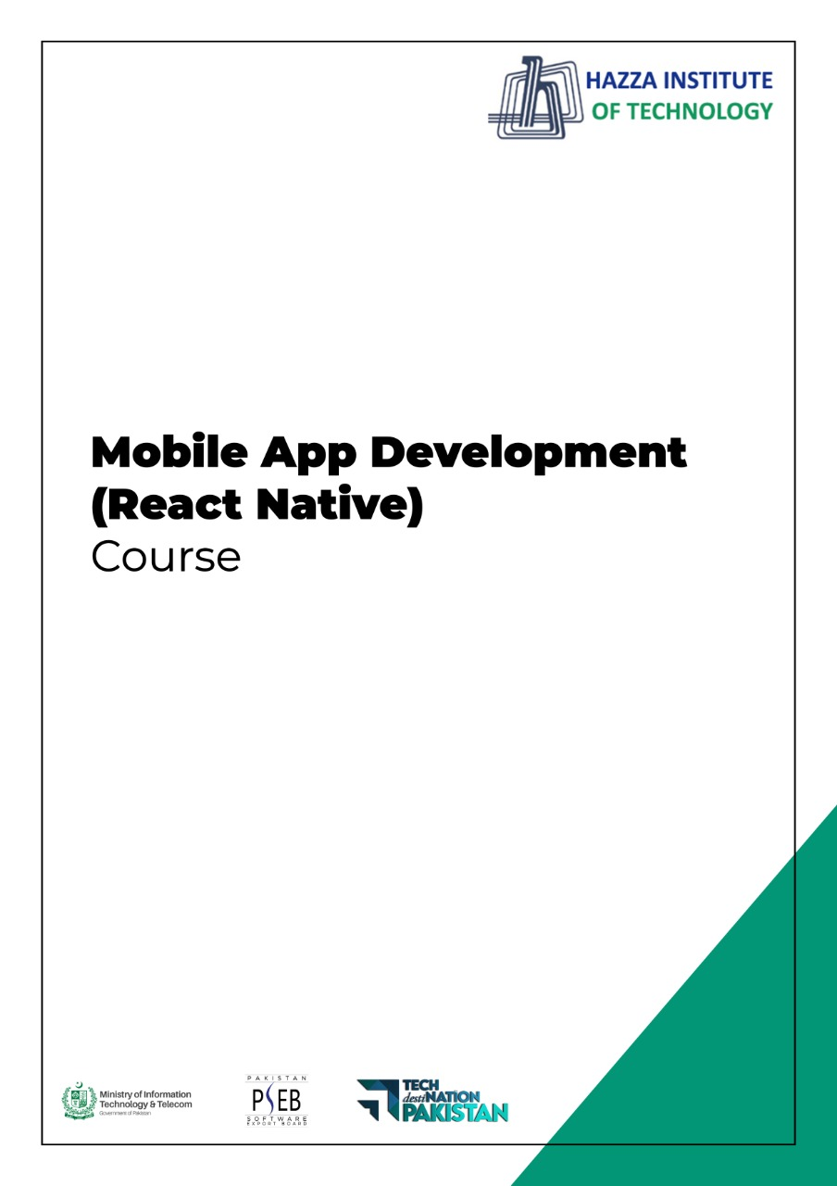
(Flutter)
Flutter Lab 11

Total Time:
3 hours (session-1)

Pre-Lab Activities:
  - Student Must have Knowledge about UI design.

Learning Outcomes:
  - Students will learn workingwith multiple screens
  - Students will learn about Navigator

Student Activities:
  - Design different screens
  - Navigate from one screen to another

Lab Tasks 1:
Create an app having three screen i.e home screen, second screen and third screen

  - In home screen there is one TextField and two buttons
  - When button ( Go to second screen ) is pressed, navigate to second screen alongwith the data in textfield
  - When button ( Go to third screen ) is pressed, navigate to third screen alongwith the data in textfield
  - Please note that second screen is stateless and third screen is stateful.
  - Show data accordingly

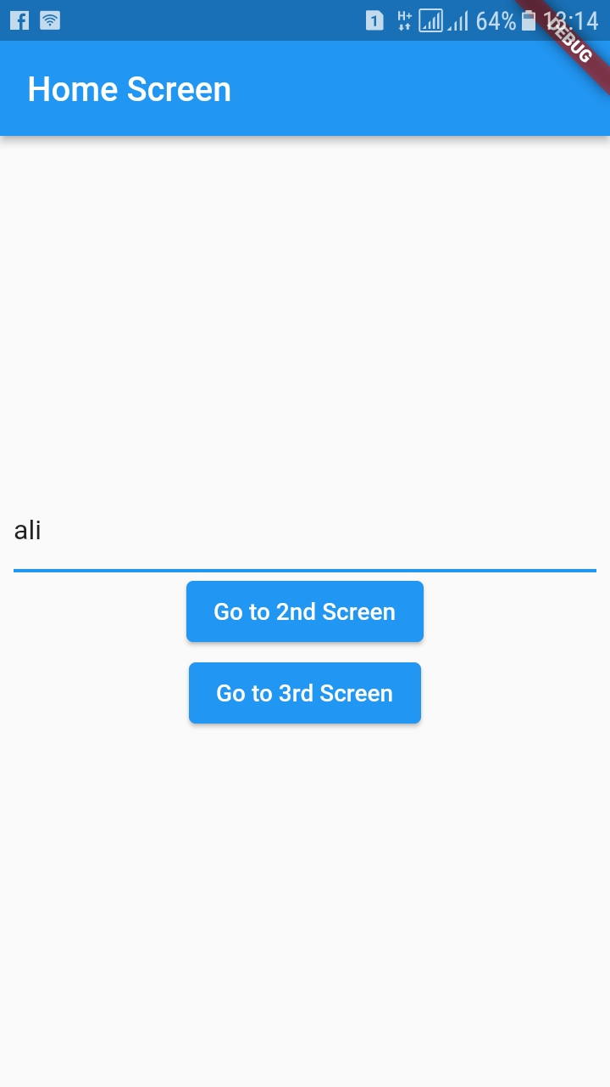

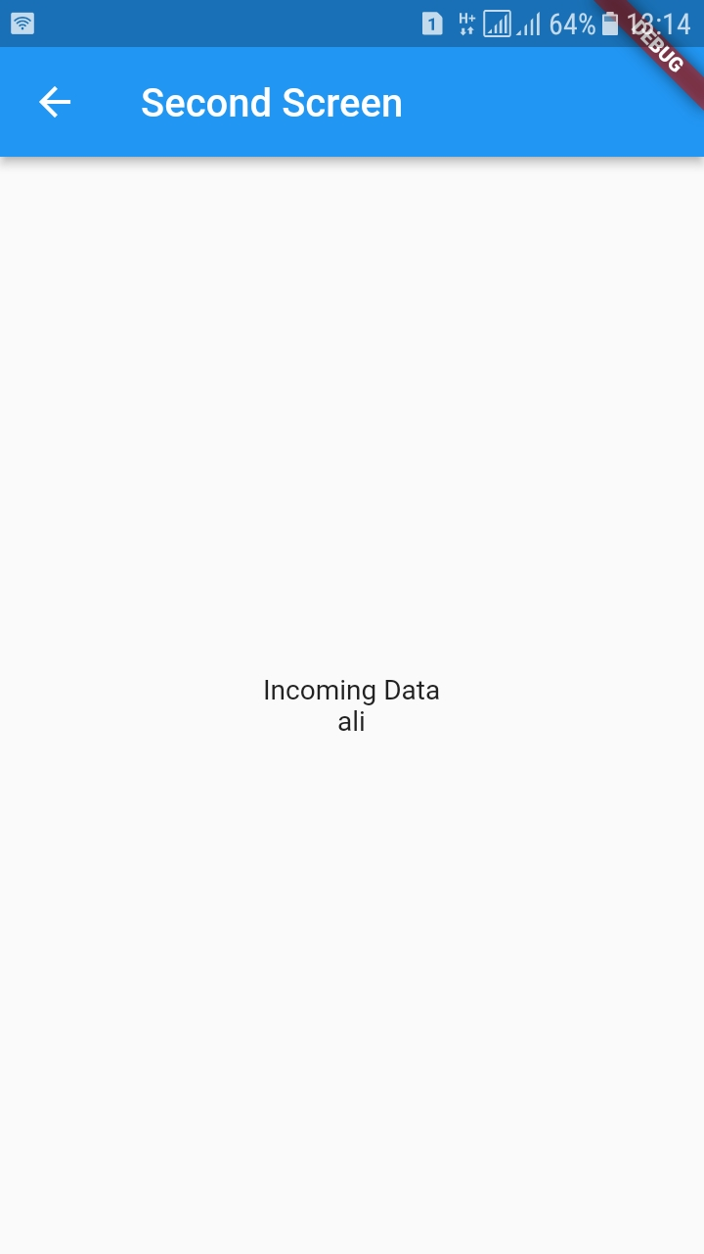

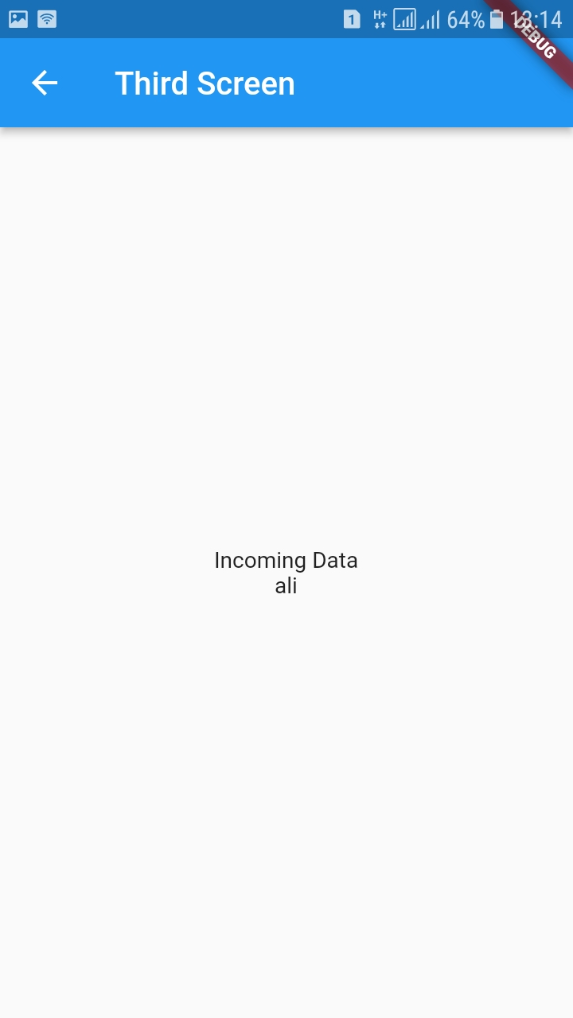

Lab Solutions:

LAB 11.a :
main.dart
import 'package:flutter/material.dart';
import 'package:navigator_pseb_bridge_10a/screens/home_screen.dart';

void main() {
runApp(const MyApp());
}

class MyApp extends StatelessWidget {
const MyApp({Key? key}) : super(key: key);

// This widget is the root of your application.
@override
Widget build(BuildContext context) {
return MaterialApp(
title: 'Flutter Demo',
theme: ThemeData(
primarySwatch: Colors.blue,
),
home: const HomeScreen(),
);
}
}

Home_screen.dart
import 'package:flutter/material.dart';
import 'package:navigator_pseb_bridge_10a/screens/second_screen.dart';
import 'package:navigator_pseb_bridge_10a/screens/third_screen.dart';

class HomeScreen extends StatefulWidget {
const HomeScreen({Key? key}) : super(key: key);

@override
State<HomeScreen> createState() => _HomeScreenState();
}

class _HomeScreenState extends State<HomeScreen> {
var nameController = TextEditingController();

@override
Widget build(BuildContext context) {
return Scaffold(
appBar: AppBar(
title: const Text('Home Screen'),
),

body: Center(
child: Padding(
padding: const EdgeInsets.all(8.0),
child: Column(
mainAxisSize: MainAxisSize.min,
children: [

TextField(
controller: nameController,
decoration: const InputDecoration(
hintText: 'Name',
),
),
ElevatedButton(onPressed: (){
Navigator.of(context).push(MaterialPageRoute(builder: (context){
return SecondScreen(name: nameController.text);
}));
}, child: const Text('Go to 2nd Screen')),
ElevatedButton(onPressed: (){
Navigator.of(context).push(MaterialPageRoute(builder: (context){
return ThirdScreen(name: nameController.text);
}));
}, child: const Text('Go to 3rd Screen')),

],
),
),
),
);
}
}

Second_screen.dart
import 'package:flutter/material.dart';

class SecondScreen extends StatelessWidget {
final String name;
const SecondScreen({Key? key, required this.name}) : super(key: key);

@override
Widget build(BuildContext context) {
return Scaffold(
appBar: AppBar(
title: const Text('Second Screen'),
),

body: Center(

child: Column(
mainAxisSize: MainAxisSize.min,
children: [

const Text('Incoming Data'),
Text(name)
],
),
),
);
}
}

Third_screen.dart
import 'package:flutter/material.dart';

class ThirdScreen extends StatefulWidget {

final String name;
const ThirdScreen({Key? key, required this.name}) : super(key: key);

@override
State<ThirdScreen> createState() => _ThirdScreenState();
}

class _ThirdScreenState extends State<ThirdScreen> {
@override
Widget build(BuildContext context) {
return Scaffold(
appBar: AppBar(
title: const Text('Third Screen'),
),

body: Center(
child: Column(
mainAxisSize: MainAxisSize.min,
children: [
const Text('Incoming Data'),
Text(widget.name)
],
),
),
);
}
}

Complete source code:
https://github.com/abidroid/navigator_pseb_bridge_10a

Lab 11. B

Display a list of doctors
when a doctor container is pressed, pass it to detail screen

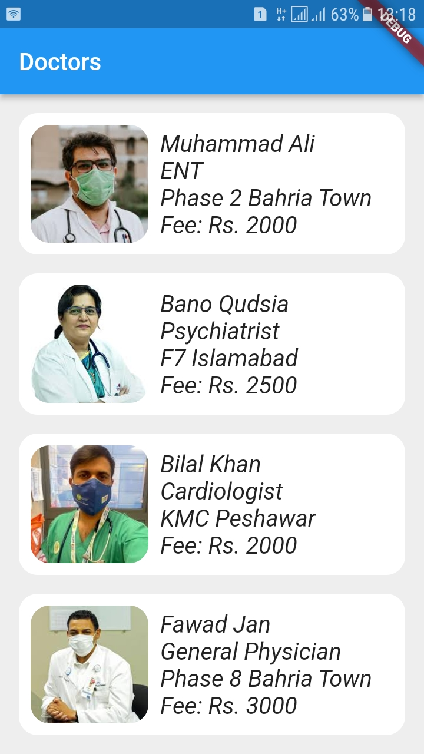

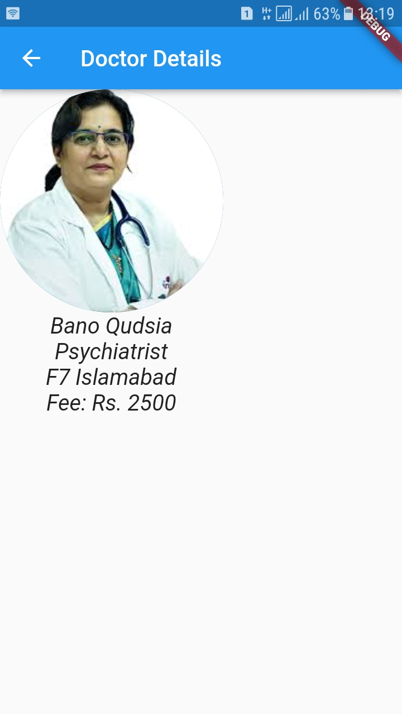

Lab 11B Solution
Main.dart
import 'package:flutter/material.dart';
import 'package:navigator_pseb_bridge_10b/screens/home_screen.dart';

void main() {
runApp(const MyApp());
}

class MyApp extends StatelessWidget {
const MyApp({Key? key}) : super(key: key);

// This widget is the root of your application.
@override
Widget build(BuildContext context) {
return MaterialApp(
title: 'Flutter Demo',
theme: ThemeData(
primarySwatch: Colors.blue,
),
home: const HomeScreen(),
);
}
}

Doctor.dart ( Model class )
class Doctor {
final String name;
final String spe;
final String clinicAddress;
final int fee;
final String photo;

Doctor({
required this.name,
required this.spe,
required this.clinicAddress,
required this.fee,
required this.photo,
});
}

Data_store.dart
import '../models/doctor.dart';

class DataStore
{

static List<Doctor> doctors = [

Doctor(name: 'Muhammad Ali', spe: 'ENT', clinicAddress: 'Phase 2 Bahria Town', fee: 2000, photo: 'assets/images/ali.jpeg'),
Doctor(name: 'Bano Qudsia', spe: 'Psychiatrist', clinicAddress: 'F7 Islamabad', fee: 2500, photo: 'assets/images/bano.jpeg'),
Doctor(name: 'Bilal Khan', spe: 'Cardiologist', clinicAddress: 'KMC Peshawar', fee: 2000, photo: 'assets/images/bilal.jpeg'),
Doctor(name: 'Fawad Jan', spe: 'General Physician', clinicAddress: 'Phase 8 Bahria Town', fee: 3000, photo: 'assets/images/fawad.jpeg'),
Doctor(name: 'Fozia Waheed', spe: 'Gynaecologist', clinicAddress: 'Baldia Town Karachi', fee: 4000, photo: 'assets/images/fozia.jpeg'),
Doctor(name: 'Hina Pervaiz', spe: 'Gastroenterologist', clinicAddress: 'Phase 2 Bahria Town', fee: 2000, photo: 'assets/images/hina.jpeg'),
Doctor(name: 'Jin Huang', spe: 'Physiotherapist', clinicAddress: 'China Town', fee: 2000, photo: 'assets/images/jin.jpeg'),
Doctor(name: 'Riaz Awan', spe: 'ENT', clinicAddress: 'Abbottabad Sadar', fee: 2000, photo: 'assets/images/riaz.jpeg'),

];
}

Home_screen.dart
import 'package:flutter/material.dart';
import 'package:navigator_pseb_bridge_10b/screens/doctor_details_stl.dart';

import '../models/doctor.dart';
import '../util/data_store.dart';
import 'doctor_details_stf.dart';

class HomeScreen extends StatelessWidget {
const HomeScreen({Key? key}) : super(key: key);

@override
Widget build(BuildContext context) {
return Scaffold(
backgroundColor: Colors.grey[200],
appBar: AppBar(
title: const Text('Doctors'),
),
body: Padding(
padding: const EdgeInsets.all(16.0),
child: ListView.builder(
itemCount: DataStore.doctors.length,
itemBuilder: (context, index) {
Doctor doctor = DataStore.doctors[index];

return GestureDetector(
onTap: () {
// Navigator.of(context)
// .push(MaterialPageRoute(builder: (context) {
// return DoctorDetailsStl(doctor: doctor);
// }));

Navigator.of(context)
.push(MaterialPageRoute(builder: (context) {
return DoctorDetailsStf(doctor: doctor);
}));
},
child: Container(
padding: const EdgeInsets.all(10),
margin: const EdgeInsets.only(bottom: 16.0),
decoration: BoxDecoration(
color: Colors.white,
borderRadius: BorderRadius.circular(16.0),
),
child: Row(
children: [
ClipRRect(
borderRadius: BorderRadius.circular(16.0),
child: Image.asset(
doctor.photo,
width: 100,
height: 100,
fit: BoxFit.cover,
)),
const SizedBox(
width: 10,
),
Column(
crossAxisAlignment: CrossAxisAlignment.start,
children: [
Text(
doctor.name,
style: const TextStyle(
fontSize: 20, fontStyle: FontStyle.italic),
),
Text(
doctor.spe,
style: const TextStyle(
fontSize: 20, fontStyle: FontStyle.italic),
),
Text(
doctor.clinicAddress,
style: const TextStyle(
fontSize: 20, fontStyle: FontStyle.italic),
),
Text(
'Fee: Rs. ${doctor.fee}',
style: const TextStyle(
fontSize: 20, fontStyle: FontStyle.italic),
),
],
)
],
),
),
);
}),
),
);
}
}

Doctor_details_stl.dart
import 'package:flutter/material.dart';

import '../models/doctor.dart';

class DoctorDetailsStl extends StatelessWidget {
final Doctor doctor;

const DoctorDetailsStl({Key? key, required this.doctor}) : super(key: key);

@override
Widget build(BuildContext context) {
return Scaffold(
appBar: AppBar(
title: const Text('Doctor Details'),
),
body: Column(
children: [
CircleAvatar(
backgroundImage: AssetImage(
doctor.photo,
),
radius: 100,
),
Text(
doctor.name,
style: const TextStyle(fontSize: 20, fontStyle: FontStyle.italic),
),
Text(
doctor.spe,
style: const TextStyle(fontSize: 20, fontStyle: FontStyle.italic),
),
Text(
doctor.clinicAddress,
style: const TextStyle(fontSize: 20, fontStyle: FontStyle.italic),
),
Text(
'Fee: Rs. ${doctor.fee}',
style: const TextStyle(fontSize: 20, fontStyle: FontStyle.italic),
),
],
),
);
}
}

Doctor_details_stf.dart
import 'package:flutter/material.dart';

import '../models/doctor.dart';

class DoctorDetailsStf extends StatefulWidget {
final Doctor doctor;

const DoctorDetailsStf({Key? key, required this.doctor}) : super(key: key);

@override
State<DoctorDetailsStf> createState() => _DoctorDetailsStfState();
}

class _DoctorDetailsStfState extends State<DoctorDetailsStf> {
@override
Widget build(BuildContext context) {
return Scaffold(
appBar: AppBar(
title: const Text('Doctor Details'),
),
body: Column(
children: [
CircleAvatar(
backgroundImage: AssetImage(
widget.doctor.photo,
),
radius: 100,
),
Text(
widget.doctor.name,
style: const TextStyle(fontSize: 20, fontStyle: FontStyle.italic),
),
Text(
widget.doctor.spe,
style: const TextStyle(fontSize: 20, fontStyle: FontStyle.italic),
),
Text(
widget.doctor.clinicAddress,
style: const TextStyle(fontSize: 20, fontStyle: FontStyle.italic),
),
Text(
'Fee: Rs. ${widget.doctor.fee}',
style: const TextStyle(fontSize: 20, fontStyle: FontStyle.italic),
),
],
),
);
}
}

Complete source code
https://github.com/abidroid/navigator_pseb_bridge_10b

